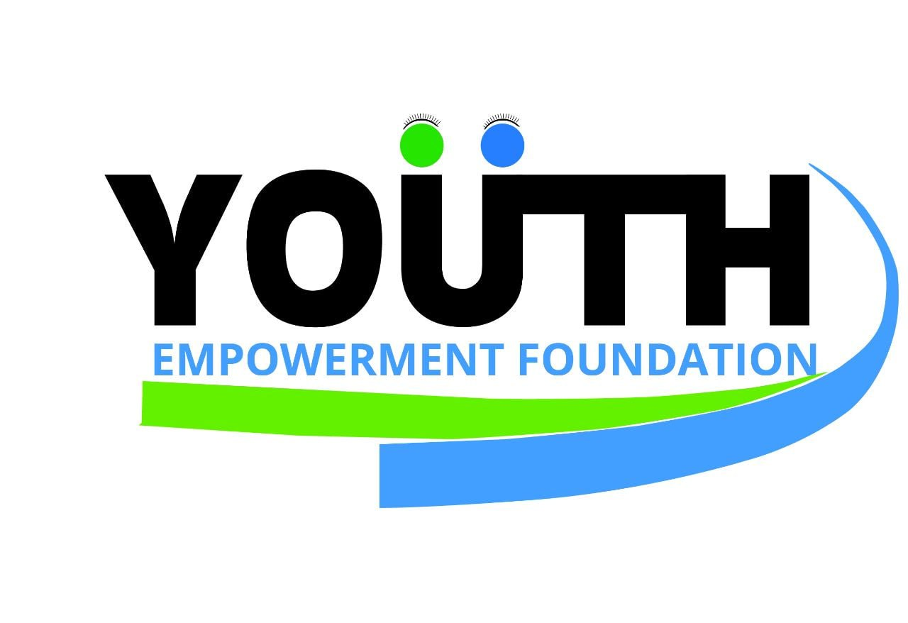

Project Title:
"SolarHarvest: Empowering Refugee Communities through Sustainable Food Security"

Project Concept:

"SunHarvest" aims to address the pressing issue of food security in refugee settlements by introducing solar dryers as an innovative and sustainable solution. This holistic initiative not only reduces post-harvest losses but also empowers refugees with a valuable skill, contributing to economic independence and overall well-being.

Problems statements
Refugee settlements are confronted with multifaceted challenges, with one of the most acute being food security in post harvests food storage. In response to this critical issue, we propose to establishment of solar dryers (prototypes) in these settlements as an innovative and sustainable solution to reduce food wastage and improve food storage, enhance food security, and improve the overall quality of life for the Refugees in the refugee settlements.

Solar Dryers:
Sun Solar dryers (SSD) harness the abundant power of the sun to dehydrate various food items, effectively preserving them for extended periods. This technology not only reduces dependency on traditional methods, such as open_air drying, which can be inefficient and prone to animals that feed on them reducing their quantity and also mitigates the risk of contamination. By installing solar dyers, we aim to empower the refugees to preserve their harvests more effectively, contributing to the reduction of post harvest losses and fostering economic independencies.

YEF will trained 5 selected householders and 15 participants, male and female youths within Pagriniya Refugee Settlement to carry out this prototypes of Solar dryer and all this training will be documents in form of OER and other open source platform like wiki-factory, and social media
(Budget 1500 euro)
project start will on 15th of Feb and end on 10th of March 2024
Aims of the Solar Dryer
- To reduce food shortage and waste management and improve post-harvest processes
- To achieve the sustainable development goals of 2030 number 2 which aims to improve security
- To equip the different locals in the community with the knowledge of this skill.
- To make it as an Open Educational resource (OER) for other people to develop and expand its existence.

Statics Research about food Insecurity and wastage in the Refugee settlement.
According to the research carried out in the community, Farmers lose 35% of their post harvest when drying. With comparison to farmer using a solar dryer, a farmer who uses a solar dryer only loses about 8% of the post harvest quantity.
It has also been proven that a farmer who uses a solar dryer has better quality and healthy post harvest after drying and this is because all the harvest is dried in an enclosed dryer free from pests and infections.

Steps and procedures to create the Solar Dryer.
- Collect the necessary requirements for making solar dryer
- Measure and cut the timber into the size you would like to make.
- Cover the surface with a black Polyvinyl Chloride
- cover the sides with a transparent material favorably glass or transparent Polyvinyl Chloride
- The solar dryer structure should always be slanting

Project Impact
Solar Dryer Technology Implementation, Educational Outreach and Skill Development, Media Campaigns for Awareness and Advocacy

Solar Dryer Construction and Installation, Utilizing locally-sourced materials like timber, nails, and PVC/glass, solar dryers will be built to facilitate faster and more efficient drying of harvests Slanting structures will be implemented for optimal sun exposure.

Community Capacity Building, Conducting training sessions to equip community members with the knowledge and skills required for solar dryer construction, operation, and maintenance. Fostering economic independence by empowering locals with a sustainable and valuable skill.

Conducting ongoing monitoring and evaluation to measure the reduction in post-harvest losses and improvements in food security.
Media Campaigns and Documentation, Implementing media campaigns to raise awareness about the benefits of solar dryers and sustainable food practices and Documenting the project's progress and success stories for future reference and replication on (OER)

Project Objectives:
Reduce food shortage and waste in refugee settlements.
Contribute to achieving Sustainable Development Goal 2 (Zero Hunger) by 2030.
Empower local communities with solar drying skills for sustainable food preservation.
Establish an Open Educational Resource (OER) for knowledge-sharing and expansion.

Advantages of SunHarvest Solar Dryers:
Faster drying of harvest, saving time and resources.
Protection from animals, dust, fungi, and rain, ensuring higher-quality dried produce.
Lower risk of spoilage due to the rapid sun drying process.
Less labor-intensive, promoting efficiency and ease of use.
Improved quality of harvest in terms of nutrients, hygiene, and color.

Materials for Solar Dryer Construction:

Timber
Nails
Wood glue
Tape measure
Hammer
Transparent Polyvinyl Chloride (PVC) or glass
Black and white polythene sheets
Masking tape
Steps and Procedures:
Gather necessary materials for solar dryer construction.
Cut and assemble timber to desired size.
Cover the surface with black PVC for efficient heat absorption.
Use transparent materials (glass or PVC) for sides.
Ensure the solar dryer structure is slanting for optimal sunlight exposure.
Budget Breakdown:

Solar dryer procurement
Installation costs
Ongoing monitoring and evaluation
Media campaigns for awareness
Training sessions for the community
Documentation of project progress and outcomes
Methodologies

Conclusion:"SolarHarvest" is a holistic initiative that seeks to create lasting positive impacts on food security within refugee settlements. We invite your support in funding this project to empower communities, reduce food wastage, and contribute to achieving the Sustainable Development Goals by 2030. Together, we can make a difference in the lives of those facing food insecurity in refugee settlements. The integration of solar dryers, scientific approaches, media usage, and youth involvement aligns seamlessly with our shared commitment to sustainable development and the empowerment of marginalized communities.

